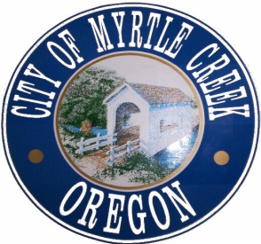
City of Myrtle Creek

City Parks Department.
207 NW Pleasant St., Myrtle Creek, Oregon 97457 • Phone (541) 863-3171 Fax (541) 863-6851

SPECIAL EVENT PERMIT APPLICATION
(Please submit 30 days prior to event)

Name of Event & Sponsoring Organization: _________________________________________

Contact Person: ______________________________ Address:_______________________________
E-mail Address: _______________________________________
Phone: ________________________
Date(s) and Time(s) of Event: _______________________________
Estimated Attendance: _________
Type of Event Activities: ____________________________________________________________________________

____________________________________________________________________________
(Please attach rules governing the event)
Location of Event (Attach site drawing, race or parade route, or floor plan):____________________________________________________________________________________________________________________________________________________

Describe City services or equipment needed (e.g. street or parking lot closure, traffic control, barricades, security and electrical hookup):_____________________________________________________________________
________________________________________________________________________________________________________________________________________________________

Private Security Provided? __Yes __No If yes, identify:_____________________________________

Number and location of Trash Receptacles: ________________________________________________

Current business License: ___Yes ___No

*Sale or Consumption of Alcohol: ___ Yes ___ No OLCC approval? ___ Yes ___ No

*Insurance requirements change if alcohol is served

AGREEMENT OF INDEMNIFICATION AND INSURANCE
__________________________ agrees to defend, save and hold harmless the City of Myrtle Creek, its officers, agents and employees from all claims, suits, or actions of whatsoever nature resulting from or arising out of the activities of the __________________________, its officers, agents and employees acting within the scope of this permit or the duties in the performance of this agreement.
__________________________ agrees to maintain liability insurance coverage of not less than $1,000,000 per occurrence for commercial general liability and automobile liability, to cover any liability arising out of or associated with this event, and agrees to name the City of Myrtle Creek, its officers, agents and employees as an additional insured on such policy with a copy of the endorsement attached to the certificate of insurance.
__________________________ further agrees to provide the City of Myrtle Creek with a certificate of liability insurance including additional insured endorsement not less than two weeks prior to the scheduled event and shall amend the notification for cancellation of coverage to 30 days. If __________________________fails to provide the certificate of insurance and endorsements within the time required herein, this Special Event Permit will automatically be revoked.

______________________________________________________________________
Signature of Authorized Agent/Date

_______________________________________Printed Name of Authorized Agent

